Design a web page (InvoiceCalculation.htmt) which calculates employee salaries according to sales.

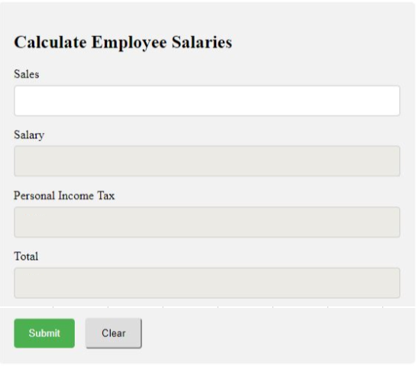

Figure 1. Calculating Employee Salary Form

Salary, Personal Income Tax, Total fields are set enable = false.

When user click submit button, perform salary calculation for employees based on this table:

|  |  |
| --- | --- |
| Level | salary |
| Level 1: sales < 5000 | 5% |
| Level 2: sales from 5000$ to 10000$ | 10% |
| Level 3: sales > 10000$ | 15% |

If Salary >=1000 then Personal Income Tax is equal 10% of salary, otherwise is 0%.

Calculating the Total with Total = Salary – Salary * Personal Income Tax;

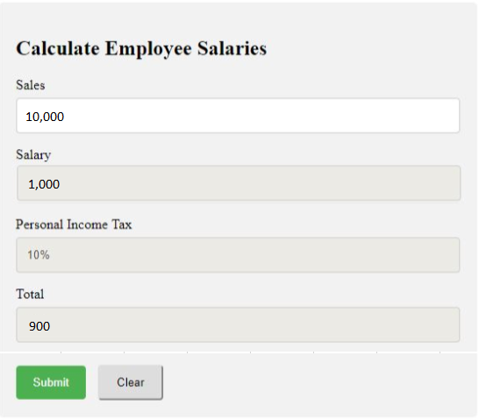

Figure 2. Example result.

When the user clicks on the Clear button, clear all the calculating data to the user ready to input new Sales value like figure 1.